Architecture
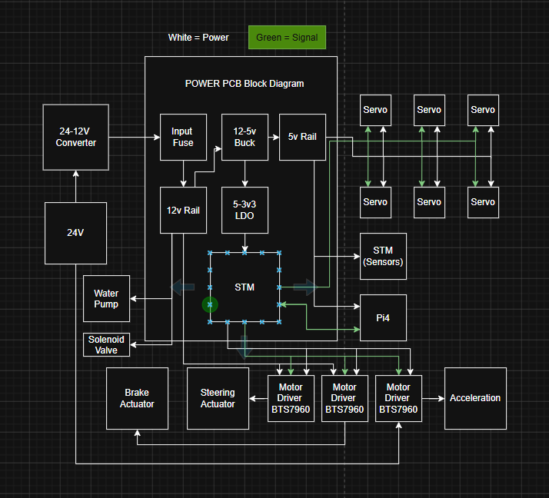

Parts outside of pcb:
- RasberryPi4
  - Vin – 5.1V
  - 3A nominal
- STM
  - Vin - 5V usb-c

- BTS7690 Motor Drivers (3)
  - Vin 6-27V
  - Control input 3v3 – 5v
  - Peak current 43A
  - Nominal current 10-15A
- 24-12V converter
  - 30A output
- Steering actuator
  - Full load draw - max current draw – 3.2A
  - Vin – 12V
  - No load draw – 1.2A
- Brake actuator
  - Vin – 12v
  - Full load current - .24A
  - 10% DC
- Motor
  - Vin 24v
  - Max/stall current – 30-40A
  - Nominal current - 10A
- Servos
- Water Pump
- Solenoid Valve

Main Parts needed on pcb:
- Input fuse
- 12v - 5v buck
- 5v - 3.3v ldo
- Stm
- Servo motor driver
- Rails for 12v, 5v, 3v3
- 12v-6v dc-dc

NSR020A0X43Z

Part selection:
- Buck Converter
  - MCP16361T-E/NMXVAO
  - LMR51403YFDBVR
  - LMR604103SRAKR
  - BD9G401EFJ-E2
  - LMR604605SVBCRQ1
  - TI LMR60440
    - 4A input
    - Variable output

- Ldo
  - TCR2EF33,LM(CT
  - TLV70033DDCR
    - 200 mA LDO

  - AP2205-W5-7

- Input fuse
  - Littelfuse MINI-FL1

  - KRDB112.5S
  - ERDM222
- STM
  - STM32G431KB
    - datasheet

Current Draws
Component | Nominal | max
Steering actuator | 1.2 | 3.2
Brake actuator | .55 | 1
STM (sensors) | .15 | .3
STM (onboard) | .1 | .2
Pi4 | 2.5 | 3
Servos (6) | 1 | 1.9
Total | 5.5 | 10.1
Motor | 10A | 30-40A

STARTING SCHEMATIC
- MAIN COMPONENTS
  - NSR020A0X43Z
  - TLV70033DDCR
  - STM32G474CBT6TR
  - LMR51450FSQDRRRQ1
  - 1206L500/12SLPR
LMR51450FSQDRRRQ1
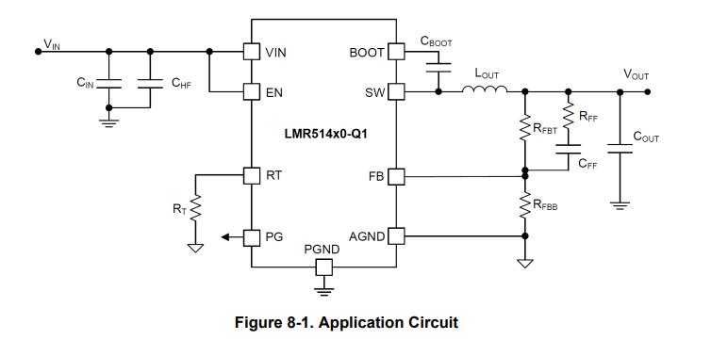
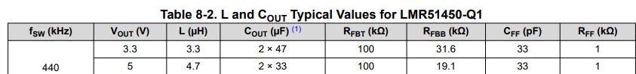

TLV70033DDCR
Recommends 1u caps for Cin and Cout
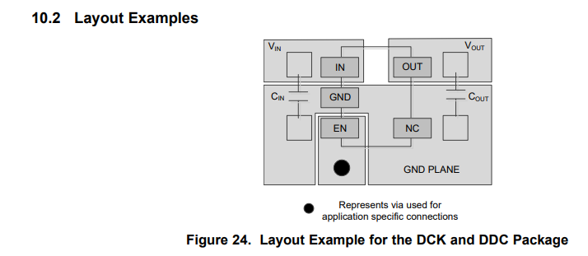
NSR020A0X43Z
Pin | Name | What it does | For your board
1 | Vout | Regulated output | Connect to 6V_SERVO or 5V_SERVO rail
2 | Trim+ | Output voltage set | One side of trim resistor
3 | GND | Ground | Connect to main GND plane
4 | PwGood | Power-good output | Optional, can go to STM input or leave unused with care
5 | On/Off | Enable pin | Leave open for always-on, or control with STM/MOSFET
6 | Vin | Input voltage | Connect to fused 12V rail
7 | Sense+ | Remote sense positive | Usually connect to Vout / servo rail
8 | Sense- | Remote sense negative | Usually connect to GND
9 | Trim- | Output voltage set reference | Other side of trim resistor
10 | GND | Ground/outrigger | Connect to main GND plane

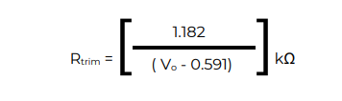

STM
NEXT STEPS
- Establish communication between Pi4 and onboard STM
  - UART between Pi and STM
    - Pi TX -> STM RX
    - Pi RX -> STM TX
    - Common GND
- Establish connection between STM and servos
  - servo receives:
    - 5V power
    - GND
    - PWM signal from STM
- Establish connection between STM and BTS7960 motor drivers
  - From STM
    - PWM
    - direction / complementary control
      - maybe enable
    - Shared logic ground
  - BTS shares gnd with power as well
- Connectors
  - Bts7690’s
    - 8 pins x2
      - 2 PWM – 3v3
      - 2 EN – 3v3
      - VCC – 5v
      - 2 Gnd
      - VCC – 12v
    - 6 pins
      - 2 PWM – 3v3
      - 2 EN – 3v3
      - VCC – 5v
      - Gnd

  - Servos
    - 3 pins x 6
      - PWM -3v3
      - VCC – 5v
      - Gnd
  - Pi4
    - 6 pins
      - 2 VCC – 5v
      - 2 Gnd
      - Tx -3v3
      - Rx – 3v3
  - Stm32
    - 4 pins
      - 2 VCC
      - 2 Gnd
  - 12v connection
    - 6 pins
      - 3 VCC
      - 3 Gnd
  - Onboard stm
    - 5 pins
      - 1 VCC – 3v3
      - 1 Gnd
      - 3 Signal
        - SWDIO
        - SWCLK
        - NRST
  - Solenoid Valve
    - 2 pins
      - 1 Gnd
      - 1 VCC – 12V
  - Water Pump
    - 2 pins
      - 1 Gnd
      - 1 VCC – 12V

Qty | PCB connector | Use
7 | Molex 0430450612 — Micro-Fit 3.0, 6-position, vertical, through-hole | Pi, onboard STM programming, acceleration BTS7960 logic, 3 servo connectors, offboard STM
2 | Molex 39-28-1063 — Mini-Fit Jr., 6-position, vertical, through-hole | 12 V PCB input, solenoid/pump
2 | Molex 39-28-1083 — Mini-Fit Jr., 8-position, vertical, through-hole | Steering BTS7960, brake BTS7960

